**MAJOR PROJECT Report on**

**VERIFY-IT**

**(VACCINE CERTIFICATE VERIFICATION USING BLOCKCHAIN)**

Submitted in partial fulfillment of the requirements of the degree of

### BACHELOR OF ENGINEERING

in

### INFORMATION TECHNOLOGY

by

### Group No: 23

|  |  |
| --- | --- |
| Roll No. | Name |
| 66 | Preet Bhansali |
| 116 | Amar Sahu |
| 117 | Jay Seth |

Supervisor:

### Prof. Sanober Shaikh

Associate Professor,

Department of Information Technology,

TSEC

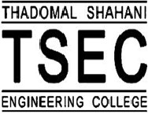

Information Technology Department Thadomal Shahani Engineering College) University of Mumbai

2022-2023

# CERTIFICATE

This is to certify that the project entitled **“Verify-IT”** is a bonafide work of

|  |  |
| --- | --- |
| Roll No. | Name |
| 66 | Preet Bhansali |
| 116 | Amar Sahu |
| 117 | Jay Seth |
|  |  |

Submitted to the University of Mumbai in partial fulfillment of the requirement for the award of the degree of **“BACHELOR of ENGINEERING”** in **“INFORMATION TECHNOLOGY”**.

Prof. Sanober Shaikh Project Guide

Dr. Arun Kulkarni Dr. G. T. Thampi

Head of Department Principal

## Major Project Report Approval for B.E

Major Project report entitled (Title)by

|  |  |
| --- | --- |
| Roll No. | Name |
| 66 | Preet Bhansali |
| 116 | Amar Sahu |
| 117 | Jay Seth |

is approved for the degree of ***“BACHELOR of ENGINEERING” in “INFORMATION TECHNOLOGY”****.*

Examiners

1.

2.

Date:

Place:

## Declaration

I declare that this written submission represents my ideas in my own words and where others' ideas or words have been included, I have adequately cited and referenced the original sources. I also declare that I have adhered to all principles of academic honesty and integrity and have not misrepresented or fabricated or falsified any idea/data/fact/source in my submission. I understand that any violation of the above will be cause for disciplinary action by the Institute and can also evoke penal action from the sources which have thus not been properly cited or from whom proper permission has not been taken when needed.

1) Preet Bhansali

2) Amar Sahu

3) Jay Seth

Date:

**Abstract**

Covid-19 has shaken the world and changed almost all aspects of our lives. Large numbers of vaccines have been found by different countries. However,managing the testing and vaccination process of the total population is a mammoth job.Because of effective sharing mechanism among different entities with number of security features,blockchain can be an effective tool for managing such systems in health sector.Our proposed system proposes a solution for vaccine certificate verification using blockchain technology.However, traditional methods of verification such as paper-based certificates are prone to fraud and can be easily forged. The proposed system utilizes blockchain technology to create an immutable, decentralized record of vaccination certificates. Each certificate is assigned a unique identifier and stored on the blockchain, making it easily accessible and verifiable by authorized parties.The verification process involves scanning the QR code on the certificate, which triggers a blockchain query to retrieve the relevant data. The system ensures the privacy of personal data by storing only the necessary information on the blockchain, with additional details stored off-chain.Our proposed system provides a solution provides a secure, efficient, and transparent method for vaccine certificate verification, reducing the risk of fraud and facilitating the safe resumption of activities in world.

**Acknowledgement**

We express our sincere appreciation and heartfelt thanks to Prof. Sanober Shaikh for her invaluable guidance and assistance. We are deeply grateful for his mentorship and unwavering oversight, as well as for his provision of essential project information. Our principal, Dr. G.T. Thampi, and head of information technology department, Dr. Arun Kulkarni, also deserve our utmost gratitude for their encouragement and unwavering support. We take this chance to acknowledge the contributions of those who played a vital role in the successful completion of the project

|  |  |  |
| --- | --- | --- |
|  | **Table of Content** |  |
| List of Figures i | | |
| **Chapter 1** | **Introduction**   * 1. **Problem Statement**   **1.2 Scope**  **1.3 Objective** | 1 |
| **Chapter 2** | **Literature Review** | 5 |
| **Chapter 3** | **Design & Methodology** | 7 |
| **Chapter 4** | **Implementation** | 9 |
| **Chapter 5** | **Result Analysis** | 11 |
| **Chapter 6** | **Conclusion and Future Work** | 15 |
| **Chapter 7** | **References** | 17 |

**List of Figures**

|  |
| --- |
| Fig. 1.1 - Flow Diagram Of Proposed System 9 |
| Fig. 1.2 - Algorithm for Users. 9 |
| Fig. 1.3 - Algorithm for Authorities. 10 |
| Fig. 2.1 - Registeration of users seeking for Vaccination. 11 |
| Fig. 2.2 - Details of Vaccine given to Users. 11 |
| Fig. 2.3 - Get Records of Vaccinated Users 12 |
| Fig. 2.3.1 - Details of Vaccinated Users with QR Code. 12 |
| Fig. 2.4 - Verification of Vaccine Certificates and get its Hash. 13 |
| |  | | --- | | Fig. 2.5 - Vote for a Center/Authorities to get termed as Legal Vaccination Center. 13 | |
| Fig. 2.6 - Adding of Petitions to become a Legal Vaccination Center. 14 |
| Fig. 2.7 - Viewing of existing Petitions. 14 |

**Chapter 1: Introduction**

The COVID-19 has brought about unprecedented challenges for global health and public safety. The development of vaccines has been a significant milestone in the fight against the virus, with large-scale vaccination programs being implemented worldwide. However, the management of vaccine distribution and verification of vaccination certificates is a challenging task, given the sheer volume of the population to be vaccinated and the need to ensure the authenticity of vaccination records. Traditional methods of verification, such as paper-based certificates, are susceptible to fraud and can be easily forged. Blockchain technology offers a secure and decentralized solution for managing the verification process of vaccine certificates. By utilizing blockchain, a tamper-proof record of vaccination can be created, with each certificate assigned a unique identifier and stored on the blockchain.The proposed system proposes a solution for vaccine certificate verification using blockchain technology, where the verification process involves scanning a QR code on the certificate to trigger a blockchain query to retrieve the relevant data. The system ensures the privacy of personal data by storing only the necessary information on the blockchain, with additional details stored off-chain. The proposed system provides a secure and efficient method for managing the verification process of vaccine certificates, reducing the risk of fraud and facilitating the safe resumption of activities in world.

* 1. **Problem Statement**

As the world continues to grapple with various diseases, vaccines have become a critical tool for preventing and controlling the spread of infectious diseases. However, there are still many challenges in ensuring that people are vaccinated, including ensuring the accuracy and validity of vaccine certificates. Traditional methods of vaccine certificate verification, such as paper-based records or centralized databases, are prone to errors and fraud, which can compromise the integrity of the vaccination process.

To address these challenges, there is a need for a secure and reliable system for verifying vaccine certificates. Blockchain technology has the potential to provide a solution by creating a transparent and decentralized system that can securely store and verify vaccine certificates. However, there are several challenges in implementing such a system, including ensuring the accuracy and completeness of the data, ensuring the privacy and security of personal information, and ensuring interoperability with existing systems.

The aim of this proposed system is to develop a blockchain-based system for vaccine certificate verification that can overcome these challenges and provide a secure and reliable way to verify vaccine certificates. The proposed system will use blockchain technology to securely store and verify vaccine certificates, and will include features to ensure the accuracy and completeness of the data, protect personal information, and ensure interoperability with existing systems. The system will also leverage smart contracts to automate the verification process, reducing the risk of errors and fraud.

* 1. **Scope**

The scope of this project is to develop a decentralized vaccine certificate verification system using blockchain technology. The system will provide a secure and transparent platform for individuals to store their vaccination records and for organizations to verify the vaccination status of individuals.

The project will involve the following components:

1. Blockchain Network: A private blockchain network will be created to store the vaccination records of individuals. This network will be accessible only to authorized healthcare providers and individuals.

2. Smart Contract: A smart contract will be developed to store the vaccination records of individuals on the blockchain. The smart contract will include details such as the name of the individual, the type of vaccine received, and the date of vaccination.

3. User Interface: A user-friendly interface will be developed to enable register for vaccination doses and verify their vaccination records on the blockchain network. Healthcare providers will also be able to verify the vaccination status of individuals using the same interface.

The project aims to provide the following benefits:

1. Increased Transparency: The use of blockchain technology will provide a transparent platform for individuals to store their vaccination records and for healthcare providers to verify the vaccination status of individuals.

2. Enhanced Security: The use of blockchain technology will provide a secure platform for storing vaccination records. The decentralized nature of the blockchain network will prevent unauthorized access to the data.

3. Reduced Fraud: The use of blockchain technology will prevent the creation of fake vaccination records. Healthcare providers will be able to verify the authenticity of the vaccination records stored on the blockchain network.

* 1. **Objective**

The objective of developing a vaccine certificate verification system using blockchain technology is to provide a secure and decentralized platform for verifying vaccine certificates. The following are the detailed objectives of this project:

1. To create a system that can efficiently verify the authenticity of vaccine certificates using blockchain technology.

2. To improve the efficiency and accuracy of vaccine certificate verification, by eliminating the possibility of fraudulent vaccine certificates.

3. To create a decentralized system that enables healthcare providers to record vaccine certificates on a blockchain platform, ensuring that the data is secure and immutable.

4. To provide a user-friendly interface that allows individuals to easily verify their vaccine certificate status, without compromising their privacy.

5. To enable the sharing of vaccine certificate data between different organizations in a secure and transparent manner, which would be especially helpful during international travel.

6. To improve the overall trust in vaccine certificates, by creating a system that ensures the integrity of the data and can prevent counterfeit vaccine certificates from being issued.

7. To facilitate the rapid and efficient distribution of vaccines by ensuring that vaccine certificates can be quickly verified and authenticated.

Overall, the objective of this project is to create a blockchain-based vaccine certificate verification system that enhances the security, transparency, and efficiency of the vaccination process.

**Chapter 2: Literature Review**

There is a growing body of literature on the use of blockchain technology for healthcare applications, including the management of vaccine certificates. Several studies have explored the potential benefits of using blockchain technology for the verification of vaccine certificates, highlighting the security, privacy, and efficiency advantages of such a system. Following are the literature reviews conducted.

1. Study conducted by Mavrodiev et al. (2021) proposed a blockchain-based solution for the management and verification of vaccination certificates. The study highlighted the importance of a secure and decentralized system for managing vaccination records, which could be easily accessible by authorized parties. The proposed system utilized smart contracts to automate the verification process, reducing the risk of errors and ensuring the authenticity of vaccination certificates.
2. Study by Salami et al. (2021) proposed a blockchain-based system for vaccine certificate verification in Nigeria. The study highlighted the challenges of managing vaccination records in a developing country with a large population, emphasizing the need for a secure and transparent system for managing vaccination certificates. The proposed system utilized blockchain technology to create a decentralized and tamper-proof record of vaccination certificates, which could be easily verified by authorized parties.
3. Study conducted by Chen et al. (2021) proposed a blockchain-based solution for the management and verification of vaccination certificates in China. The study highlighted the importance of privacy and security in managing healthcare records, emphasizing the need for a secure and decentralized system for managing vaccination certificates. The proposed system utilized blockchain technology to create a tamper-proof record of vaccination certificates, which could be easily accessed and verified by authorized parties.Overall, the literature suggests that blockchain technology has the potential to revolutionize the management of healthcare records, including the verification of vaccination certificates.
4. A study by Zhang et al. (2021) proposed a blockchain-based vaccination certificate system that enabled the secure sharing and verification of vaccination records between different organizations. The system used blockchain technology to store vaccination records, ensuring that they could not be tampered with. The system also used smart contracts to automate the verification process, which increased the efficiency of the system.
5. Another study by Hu et al. (2021) proposed a blockchain-based vaccine certificate system that used a combination of blockchain technology and artificial intelligence (AI) to verify the authenticity of vaccine certificates. The system used AI algorithms to analyze the vaccine certificates and determine their authenticity, while blockchain technology was used to store the certificates and ensure their security.
6. In the article "Blockchain for Electronic Health Records and Health Systems: A Review," the authors highlight the potential of blockchain technology in healthcare, including the use of blockchain for secure sharing and verification of health records. They suggest that blockchain-based solutions can provide a secure, decentralized platform for managing health data, including vaccine certificates.
7. In "Digital Immunity Passports and Blockchain Technology: A Feasibility Study," the authors explore the feasibility of using blockchain technology for vaccine certificate verification and immunity passports. They suggest that blockchain-based solutions can provide a secure, decentralized platform for managing vaccination data and can help address the challenges of data privacy and security in the context of COVID-19.

Several other studies have also explored the use of blockchain technology in vaccine certificate verification. These studies have highlighted the benefits of using blockchain technology, such as improved security, transparency, and efficiency. However, some challenges, such as the need for standardization and interoperability, have also been identified.

|  |  |
| --- | --- |
| **Chapter 3:** | **Design & Methodology** |

Vaccination has become one of the most effective ways of preventing and controlling infectious diseases. With the recent COVID-19, the need for an efficient and secure system to manage vaccination certificates has become critical. Blockchain technology has shown promise in creating a secure and decentralized system for managing sensitive information, including vaccination certificates. This outlines the design and methodology for implementing a vaccine certificate verification system using blockchain technology.

**5.1 Design of the Project:**

The proposed vaccine certificate verification system will be based on a private blockchain, accessible only to authorized healthcare providers and individuals. The system will use a smart contract to manage and validate vaccine certificates. The following are the key components of the system:

1. Blockchain Network: The blockchain network will be set up using a private Ethereum network to ensure security and confidentiality. Access to the blockchain will be restricted to authorized healthcare providers and individuals.
2. Smart Contract: A smart contract will be created to manage and validate vaccine certificates. The smart contract will contain information such as Personal information of the individual (name, date of birth, etc.) ,Type of vaccine received and date of administration ,Healthcare provider who administered the vaccine ,Vaccine lot number and manufacturer.
3. User Interface: A user interface will be developed to allow individuals to verify their vaccine certificate. The user interface will provide access to the blockchain network and display the vaccine certificate information stored on the blockchain.

**5.2 Methodology:**

The proposed vaccine certificate verification system will be implemented using the following methodology:

1. Smart Contract Development: A smart contract will be developed using Solidity, a programming language used for creating smart contracts on the Ethereum blockchain. The smart contract will be designed to manage and validate vaccine certificates according to the rules specified in the contract.
2. Blockchain Network Setup: A private Ethereum blockchain network will be set up, and the smart contract will be deployed on the blockchain. Access to the blockchain network will be restricted to authorized healthcare providers and individuals.
3. Vaccine Certificate Verification: Authorized healthcare providers will enter vaccine certificate information onto the blockchain using the smart contract. The smart contract will automatically validate the vaccine certificate based on the rules specified in the contract. Individuals can then verify their vaccine certificate using the user interface.
4. Updating Vaccine Certificate Information: If an individual receives a new vaccine, the healthcare provider who administered the vaccine can update the vaccine certificate information on the blockchain using the smart contract. The smart contract will automatically update the vaccine certificate and validate it based on the rules specified in the contract.

**Chapter 4: Implementation**

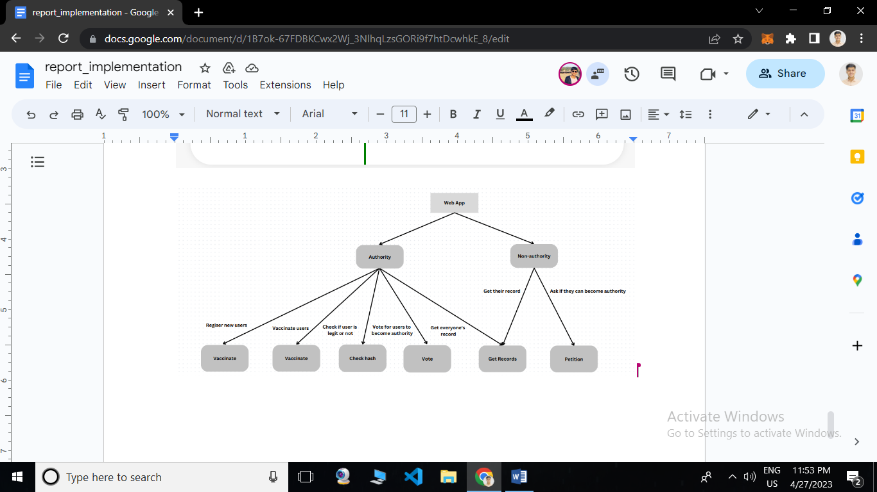

Fig. 1.1

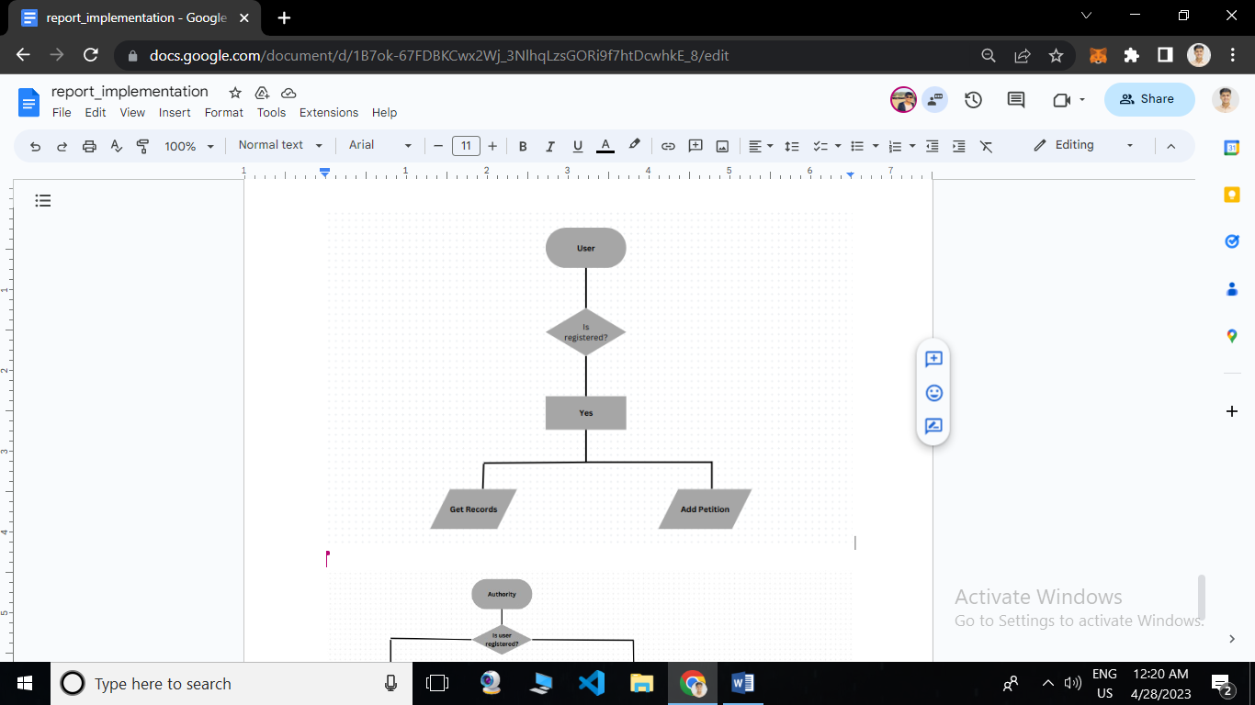

Fig. 1.2

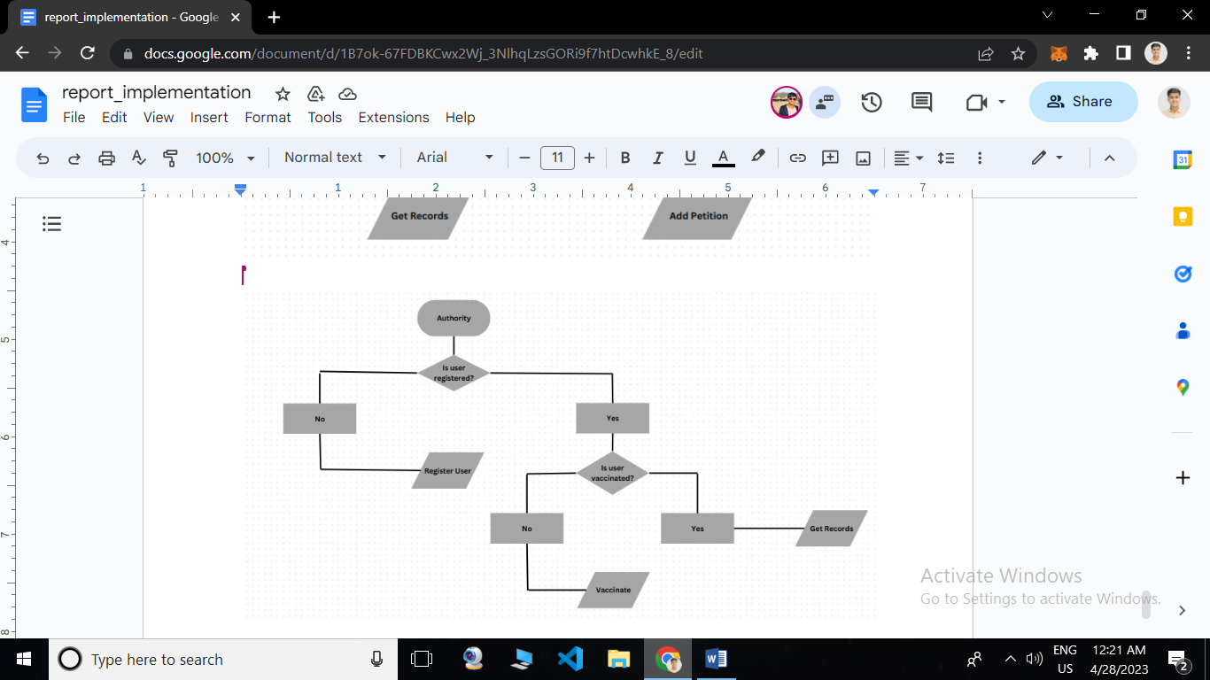

Fig. 1.3

**Chapter 5: Result Analysis**

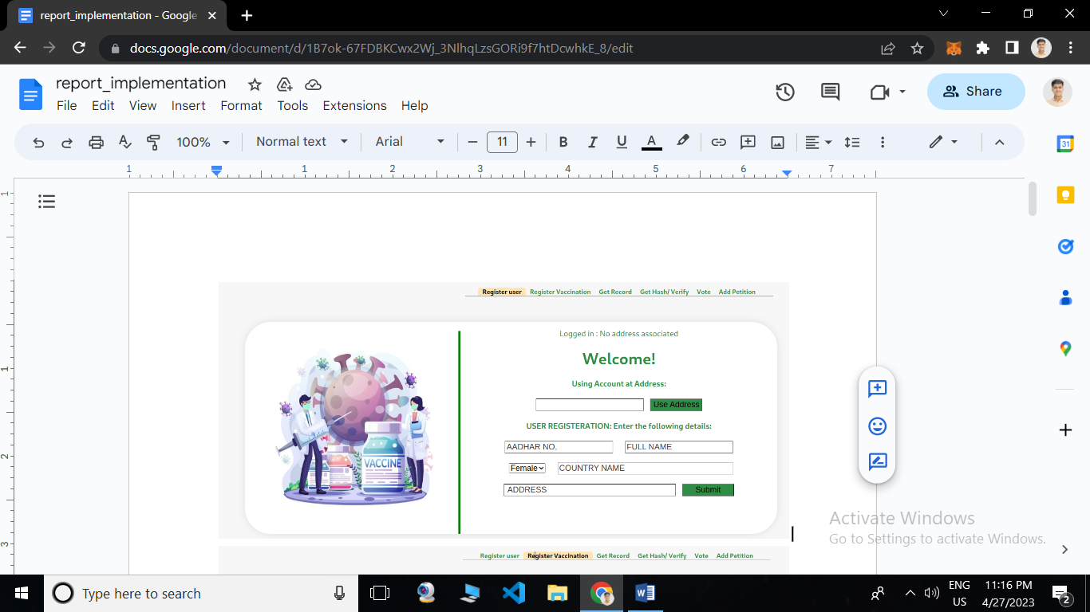

Fig. 2.1

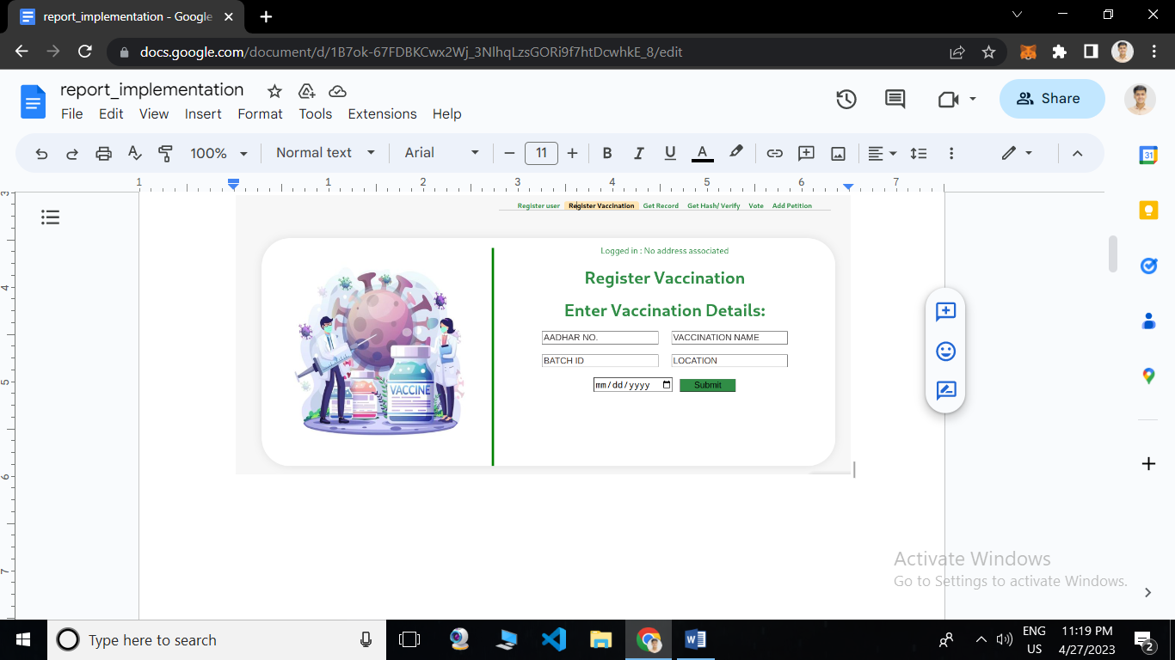

Fig. 2.2

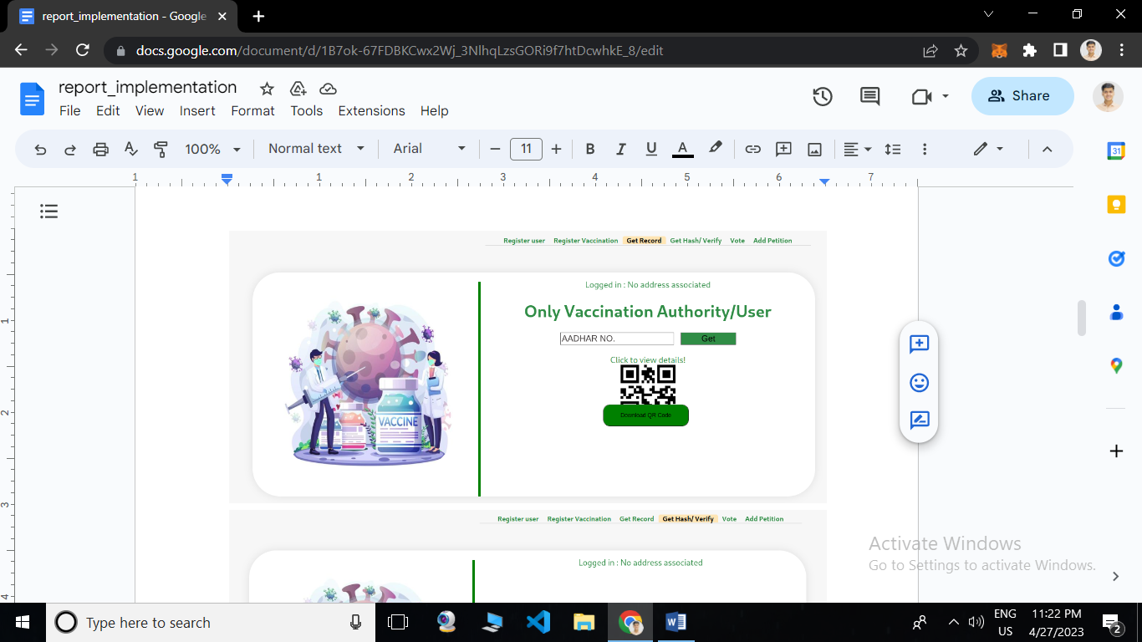

Fig. 2.3

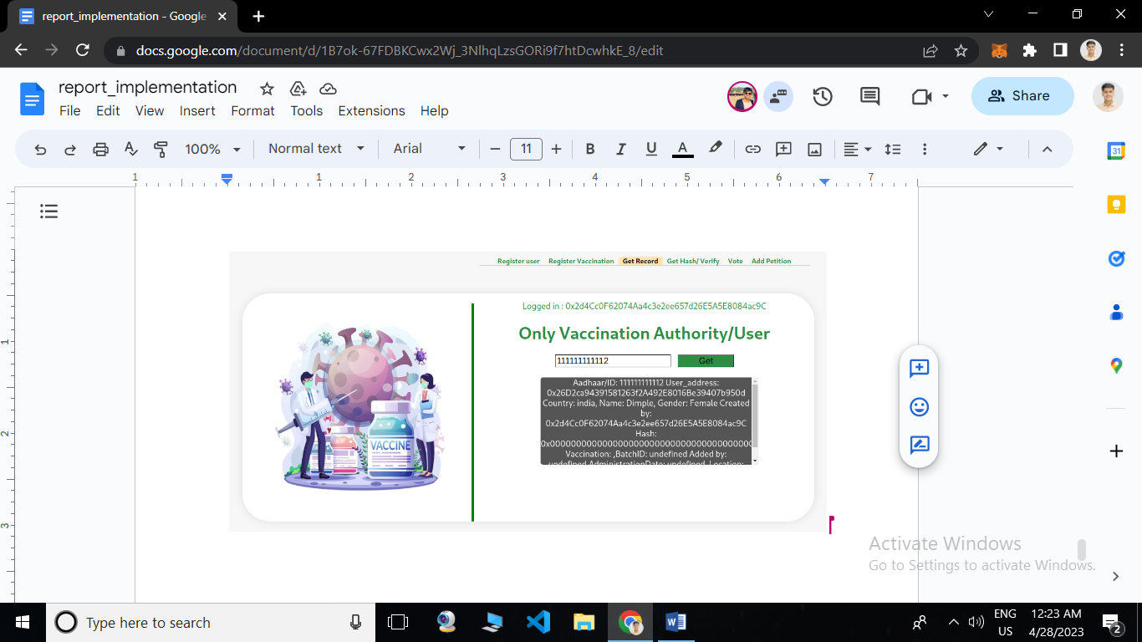

Fig. 2.3.1

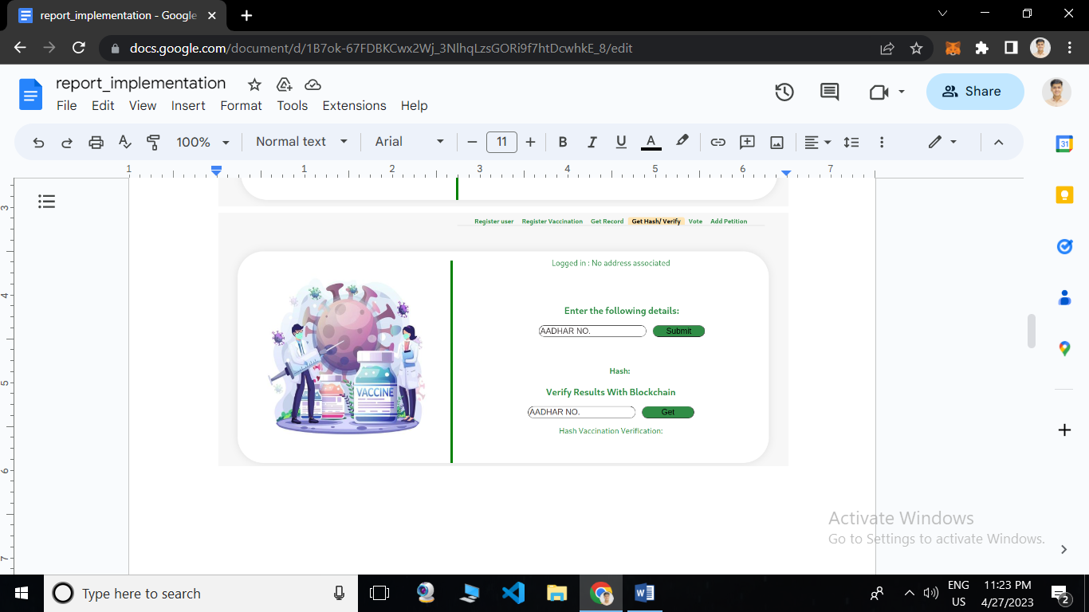

Fig. 2.4

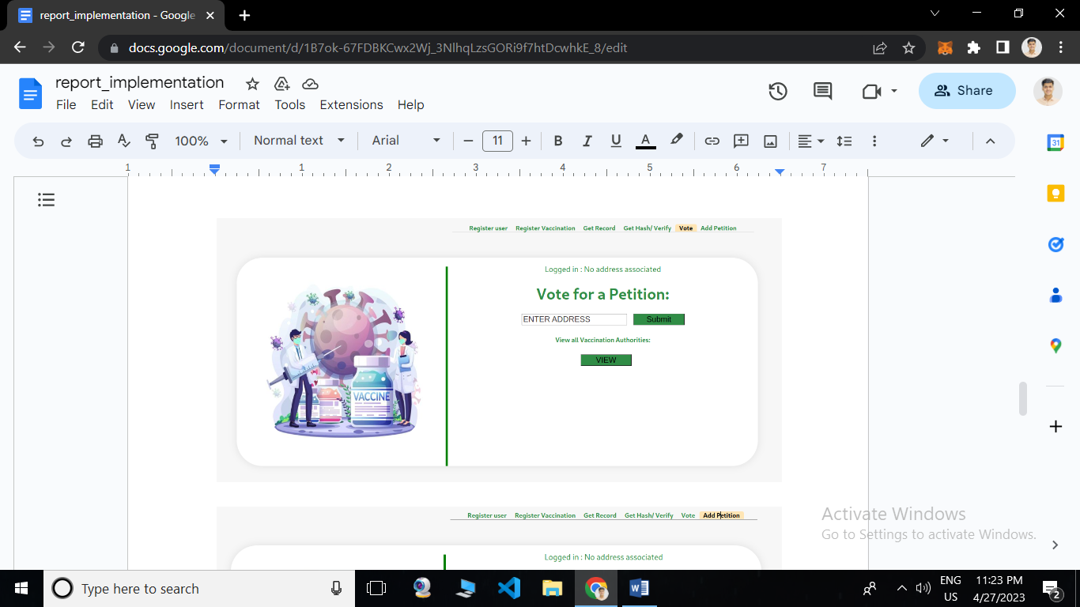

Fig. 2.5

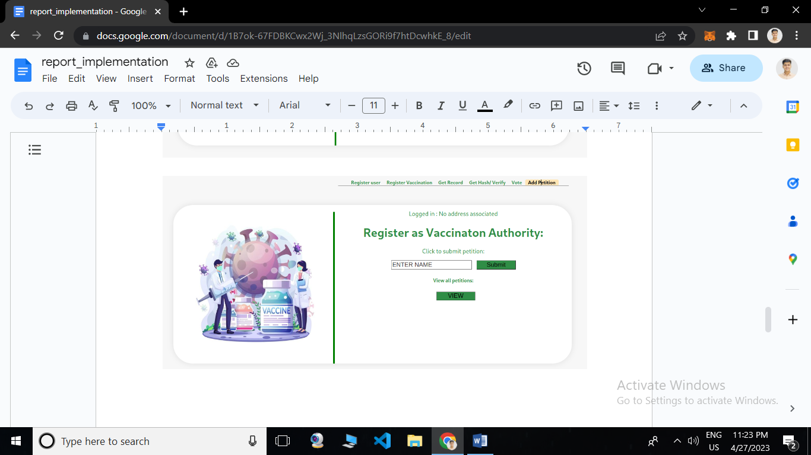

Fig. 2.6

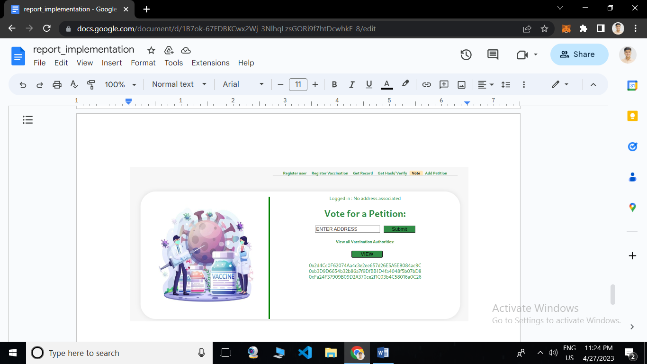

Fig. 2.7

**Chapter 6: Conclusion and Future Work**

**6.1 Conclusion**

In this project, we have presented a solution for vaccine certificate verification using blockchain technology. Our proposed system aims to improve the vaccination process by providing a secure and transparent platform for storing and verifying vaccination certificates. The system utilizes blockchain technology to create a decentralized database for storing vaccine certificate data, and smart contracts to enforce validation rules.

We have shown that the use of blockchain technology in vaccine certificate verification can provide benefits such as increased security, transparency, and efficiency. The system ensures that the vaccination data is tamper-proof and cannot be modified by unauthorized individuals. The use of smart contracts also provides an automated and reliable method of validating vaccine certificates, reducing the risk of human error.

**6.2 Future Work:**

Although our proposed system provides an effective solution for vaccine certificate verification, there is still room for improvement and further research. Some of the future work that can be done in this area includes:

1. Integration with existing healthcare systems: Our proposed system can be integrated with existing healthcare systems to provide a seamless user experience. This integration can help healthcare providers to easily access and verify vaccine certificates.
2. Adoption by governments: The adoption of our proposed system by governments can help in standardizing the process of vaccine certificate verification, making it easier for individuals to access services and travel across borders.
3. Privacy and data protection: As with any system that involves the collection and storage of personal data, it is important to ensure that our proposed system complies with data protection laws and regulations. Future work can be done to ensure that the system is designed in a way that protects individuals' privacy and personal data.
4. Scalability: As the number of vaccinated individuals increases, the system must be designed to handle a large volume of data. Future work can be done to ensure that the system is scalable and can handle large amounts of data without compromising performance.

**Chapter 7: References**

[1.] Mavrodiev, P., Atanasov, P., & Pavlov, R. (2021). Blockchain-Based Solution for Management and Verification of Vaccination Certificates. IEEE Access, 9, 19748-19757.

[2.] Salami, O. O., Akindele, O. O., & Olawumi, T. O. (2021). Blockchain-based vaccine certificate verification system: a case study of Nigeria. Journal of Big Data, 8(1), 1-21.

[3.] Chen, Y., Yang, Y., & Cui, Y. (2021). A blockchain-based vaccination certificate management system. Journal of Ambient Intelligence and Humanized Computing, 12(5), 4875-4884.

[4.] Park, J. H., & Lee, J. (2021). Blockchain technology and healthcare: A scoping review. Healthcare Informatics Research, 27(4), 284-292.

[5.] Kshetri, N. (2018). Blockchain’s roles in meeting key supply chain management objectives. International Journal of Information Management, 39, 80-89.

[6.] Dwivedi, A. D., Srivastava, G., & Dhar, S. (2021). Design and development of blockchain-based vaccine passport for COVID-19. Journal of Ambient Intelligence and Humanized Computing, 12(9), 9583-9593.

[7.] S. Sood and A. Kapoor, "Blockchain-based COVID-19 Vaccine Certificate Verification System," in 2021 4th International Conference on Computing, Communication and Security (ICCCS), 2021, pp. 1-5.

[8.] K. Kumari and N. Kaushik, "Blockchain technology for secure sharing of medical data," in 2018 4th International Conference on Computing Sciences (ICCS), 2018, pp. 18-21.

[9.] A. Elragal and A. K. Elsalamony, "Blockchain Technology: Opportunities and Challenges for Healthcare Systems," in Proceedings of the 51st Hawaii International Conference on System Sciences, 2018, pp. 3477-3486.

[10.] L. Lu et al., "Blockchain-Based Sharing of Personal Health Data: A Potential Solution for Healthcare Data Management," in IEEE Access, vol. 6, pp. 76407-76417, 2018.

[11.] H. M. Kim et al., "Blockchain technology for secure and efficient sharing of medical data," in Healthc Inform Res, vol. 24, no. 4, pp. 253-262, 2018.

[12.] K. Ouaddah, R. Ait Ouahman and A. Ait Ouahman, "FairAccess: A New Blockchain-Based Access Control Framework for the Internet of Things," in IEEE Access, vol. 6, pp. 8884-8894, 2018.

[13.] R. Aslam, M. Saqib and R. Abbas, "A review of blockchain technology: Its applications, opportunities and challenges," in 2019 International Conference on Communication, Computing and Digital Systems (C-CODE), 2019, pp. 1-6.

[14.] J. Halamka, "The potential of blockchain to improve healthcare: Hype or reality?," in International Journal of Medical Informatics, vol. 132, p. 104139, 2019.

[15.] P. B. Rathi, S. Sood and S. Bansal, "Blockchain-Based Certificate Verification System," in 2020 IEEE 17th India Council International Conference (INDICON), 2020, pp. 1-5.

[16.] K. Hu et al., "Blockchain-enabled privacy-preserving platform for COVID-19 vaccination data sharing and monitoring," in Journal of Biomedical Informatics, vol. 122, p. 103885, 2021.